Use this reference to view, add, edit, or remove an emergency contact in Workday.

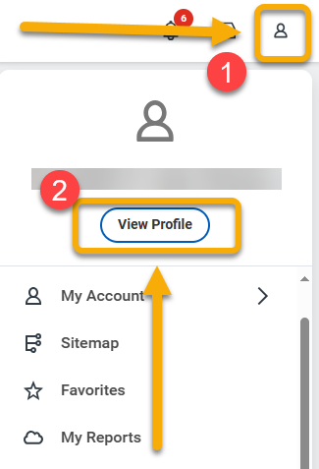
VIEW CONTACTS

- Log into Workday. Click the Profile icon in the top right corner.

- Click “View Profile”.

- Click “Contact”.

- Click the “Friends and Family” tab.

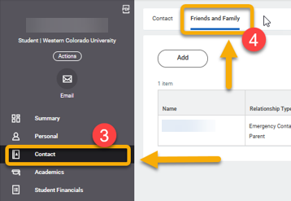
- On the Friends and Family tab, you will see a table of your contacts. To view more information, click the contact name.

TIP: There must be at least one person designated as “Emergency Contact” and one person as “Parent”. In the example below, both labels are applied to the same person.

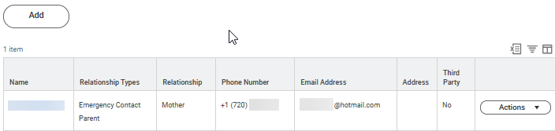

ADD CONTACT

- From the Friends and Family tab, click “Add”.

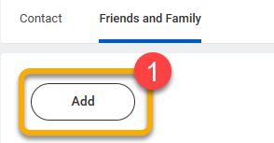

- On the Add My Friends and Family page, review the top portion of the form. Select “Relationship Type”. This is a required field.

In this example, the new contact is both the emergency contact and a parent.
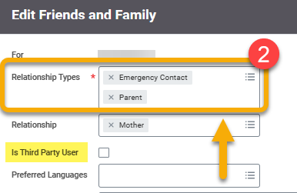
TIP: Workday requires at least one contact be labeled with “Parent” and/or “Emergency Contact”. These labels can be assigned to the same contact or two different contacts.

TIP: Click Third Party User if you want the option to give this contact access to your academic information under their own login. If checked, you will receive set-up instructions in “My Tasks”.
- Scroll down to the Name section. If there is not a blue line under Name, click to select. Complete required fields.

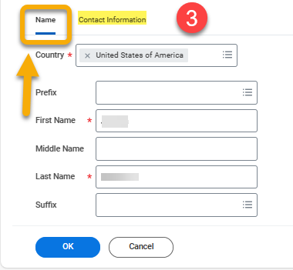

- Click “Contact Information” and complete required fields.

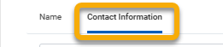

- When finished, click “OK”.



- Click “Done”.



EDIT CONTACT

- From the Friends and Family tab, identify the contact you want to edit. Scroll to the right, and click the “Actions” button to reveal a drop-down menu. Select “Edit Friends and Family”.

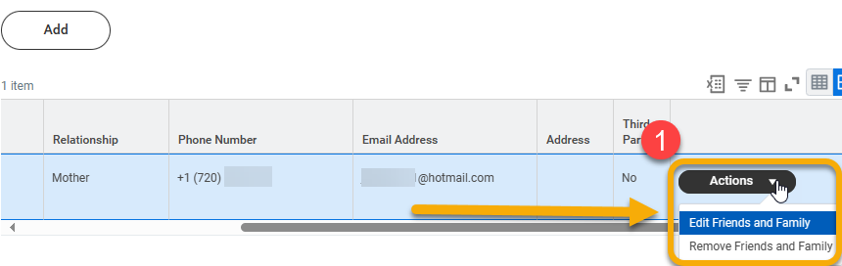

- From the Edit Friends and Family page, review the information and make changes.

- When finished, click “OK” and click “Done”.

REMOVE CONTACT

- From the Friends and Family tab, identify the contact you want to remove. Scroll to the right, and click the “Actions” button to reveal a drop-down menu. Select “Remove Friends and Family”.



- Click the “Confirm” box. Click “OK”.

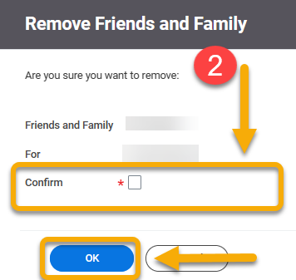

- Click “Done”.

